Subject: IT 221 - IT ELECTIVE 3 – WEB SYSTEM & TECHNOLOGIES
Prof: Leo P. Paliuanan
leopaliuanan@csu.edu.ph

UNIT 2 – Introduction to HTML and CSS

Topics
  - HTTP,
  - HTML
  - HTML 5 Tags,
  - Static and Dynamic web,
  - CSS & CSS 3 and;
  - JQuery
  - JavaScript

At the end of this course, you will be able to identify the ff:

- What is HTTP,
- What is HTML and HTML 5 tags
- What is static and dynamic web and;
- What is CSS and CSS 3
- What is Jquery and JavaScript
Course Content

- HTTP

HTTP
is how web browsers request web pages. It was one of the three main technologies defined by Tim Berners-Lee when he invented the web, along with unique identifiers for resources (which is where Uniform Resource Locators, or URLs, came from) and Hypertext Markup Language (HTML).
Other parts of the internet have their own protocols and standards to define how they work and how their underlying messages are routed through the internet (such as email with SMTP, IMAP, and POP).
When examining HTTP, you’re dealing primarily with the World Wide Web. This line is getting more blurred, however, as services built on top of HTTP, even without a traditional web front end, mean that defining the web itself is trickier and trickier!

These services (known by acronyms such as REST or SOAP) can be used by web pages and non-web pages (such as mobile apps) alike. The IoT simply represents devices that expose services that other devices (computers, mobile apps, and even other IoT devices) can interact with, often through HTTP calls. As a result, you can use HTTP to send a message to a lamp to turn it on or off from a mobile phone app
Suppose that you fire up a browser and go to www.google.com. Within a few seconds, the following will have happened, as illustrated in figure 1.1:
- The browser requests the real address of www.google.com from a Domain Name System (DNS) server, which translates the human-friendly name www.google.com to a machine-friendly IP address. If you think of an IP address as a telephone number, DNS is the telephone book. This IP address is either an older-format IPv4 address (such as 216.58.192.4, which is nearly human-usable) or a new-format IPv6 address (such as 2607:f8b0:4005:801:0:0:0:2004, which is definitely getting into “machines-only” territory).

IP is used to direct traffic through the internet (hence, the name Internet Protocol!), but TCP adds stability and retransmissions to make the connection reliable (“Hello, did you get that?” “No, could you repeat that last bit, please?”). As these two technologies are often used together, they’re usually abbreviated as TCP/IP, and, together, they form the backbone of much of the internet. A server can be used for several services (such as email, FTP, HTTP, and HTTPS [HTTP Secure] web servers), and the port allows different services to sit together under one IP address, much as a business may have a telephone extension for each employee.

When the browser has a connection to the web server, it can start asking for the website. This step is where HTTP comes in, and I examine how it works in the next section. For now, be aware that the web browser uses HTTP to ask the Google server for the Google home page.

Fig 1.1
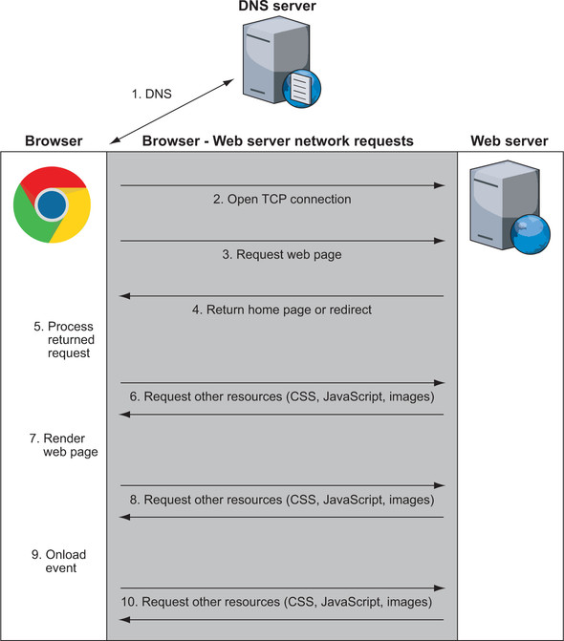

- HTML

What is HTML?
- HTML stands for Hyper Text Markup Language
- HTML is the standard markup language for creating Web pages
- HTML describes the structure of a Web page
- HTML consists of a series of elements
- HTML elements tell the browser how to display the content
- HTML elements label pieces of content such as "this is a heading", "this is a paragraph", "this is a link", etc.

A Simple HTML Document

Example
<!DOCTYPE html>
<html>
<head>
<title>Page Title</title>
</head>
<body>
<h1>My First Heading</h1>
<p>My first paragraph.</p>
</body>
</html>

Example Explained
- The <!DOCTYPE html> declaration defines that this document is an HTML5 document
- The <html> element is the root element of an HTML page
- The <head> element contains meta information about the HTML page
- The <title> element specifies a title for the HTML page (which is shown in the browser's title bar or in the page's tab)
- The <body> element defines the document's body, and is a container for all the visible contents, such as headings, paragraphs, images, hyperlinks, tables, lists, etc.
- The <h1> element defines a large heading
- The <p> element defines a paragraph

What is an HTML Element?
An HTML element is defined by a start tag, some content, and an end tag:
<tagname> Content goes here... </tagname>
The HTML element is everything from the start tag to the end tag:
- <h1>My First Heading</h1>
- <p>My first paragraph.</p>

Start tag | Element content | End tag
<h1> | My First Heading | </h1>
<p> | My first paragraph. | </p>
<br> | none | none

Web Browsers
The purpose of a web browser (Chrome, Edge, Firefox, Safari) is to read HTML documents and display them correctly.
A browser does not display the HTML tags, but uses them to determine how to display the document:
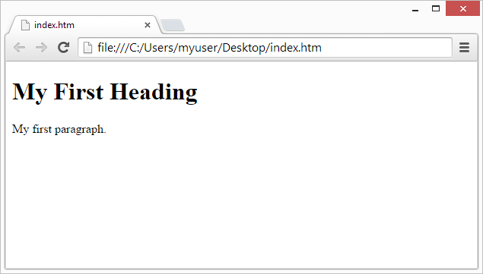

HTML Page Structure
Below is a visualization of an HTML page structure:
<html>
<head>
<title>Page title</title>
</head>
<body>
<h1>This is a heading</h1>
<p>This is a paragraph.</p>
<p>This is another paragraph.</p>
</body>
</html>

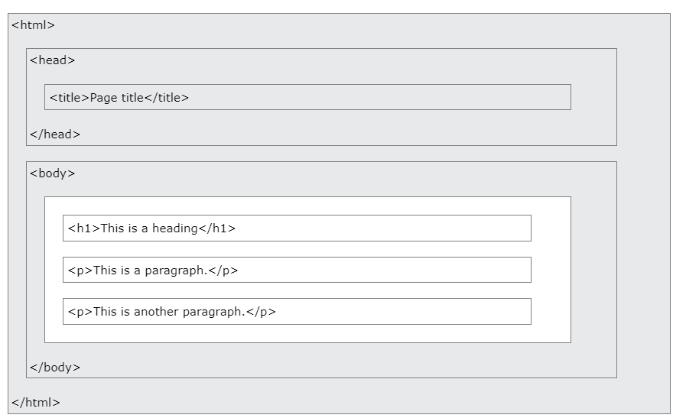
Note: The content inside the <body> section (the white area above) will be displayed in a browser. The content inside the <title> element will be shown in the browser's title bar or in the page's tab.

HTML History
Since the early days of the World Wide Web, there have been many versions of HTML:
Year | Version
1989 | Tim Berners-Lee invented www
1991 | Tim Berners-Lee invented HTML
1993 | Dave Raggett drafted HTML+
1995 | HTML Working Group defined HTML 2.0
1997 | W3C Recommendation: HTML 3.2
1999 | W3C Recommendation: HTML 4.01
2000 | W3C Recommendation: XHTML 1.0
2008 | WHATWG HTML5 First Public Draft
2012 | WHATWG HTML5 Living Standard
2014 | W3C Recommendation: HTML5
2016 | W3C Candidate Recommendation: HTML 5.1
2017 | W3C Recommendation: HTML5.1 2nd Edition
2017 | W3C Recommendation: HTML5.2

- HTML 5 Tags

HTML Documents
All HTML documents must start with a document type declaration: <!DOCTYPE html>.
The HTML document itself begins with <html> and ends with </html>.
The visible part of the HTML document is between <body> and </body>.
This follows the latest HTML 5 standard.

Example
<!DOCTYPE html>
<html>
<body>
<h1>My First Heading</h1>
<p>My first paragraph.</p>
</body>
</html>

The <!DOCTYPE> Declaration
The <!DOCTYPE> declaration represents the document type, and helps browsers to display web pages correctly.
It must only appear once, at the top of the page (before any HTML tags).
The <!DOCTYPE> declaration is not case sensitive.
The <!DOCTYPE> declaration for HTML5 is:
<!DOCTYPE html>

HTML Headings
HTML headings are defined with the <h1> to <h6> tags.
<h1> defines the most important heading. <h6> defines the least important heading:

Example
<h1>This is heading 1</h1>
<h2>This is heading 2</h2>
<h3>This is heading 3</h3>

HTML Paragraphs
HTML paragraphs are defined with the <p> tag:

Example
<p>This is a paragraph.</p>
<p>This is another paragraph.</p>

HTML Links
HTML links are defined with the <a> tag:

Example
<a href="https://www.w3schools.com">This is a link</a>
The link's destination is specified in the href attribute.
Attributes are used to provide additional information about HTML elements.
You will learn more about attributes in a later chapter.

HTML Images
HTML images are defined with the <img> tag.
The source file (src), alternative text (alt), width, and height are provided as attributes:

Example
<img src="w3schools.jpg" alt="W3Schools.com" width="104" height="142">
Try it Yourself »

How to View HTML Source
Have you ever seen a Web page and wondered "Hey! How did they do that?"

View HTML Source Code:
Right-click in an HTML page and select "View Page Source" (in Chrome) or "View Source" (in Edge), or similar in other browsers. This will open a window containing the HTML source code of the page.

Inspect an HTML Element:
Right-click on an element (or a blank area), and choose "Inspect" or "Inspect Element" to see what elements are made up of (you will see both the HTML and the CSS). You can also edit the HTML or CSS on-the-fly in the Elements or Styles panel that opens.

- Static and Dynamic web

Static vs. dynamic websites
Websites are examples of how systems can work dynamically or statically. When a user requests a webpage, the web server where the page is stored returns the Hypertext Markup Language (HTML) document to the user's computer, and the browser displays it.

On a static webpage, this process is the only action that happens. The user might interact with the document, but it has no capacity to return information that is not pre-formatted. On a dynamic webpage, the user can make requests for data contained in a database on the server that will be assembled on the fly according to what is requested.

Static webpages are better suited for information that rarely changes, while dynamic webpages are better suited for ever-changing content such as forms, search functions or comment sections.

Static and dynamic terminology. Static and dynamic can relate to a number of different topics, such as websites, Internet Protocol (IP) addresses, programming languages, marketing content, cloud computing subscriptions and data hashing.

Websites

Static websites don't use external databases, are written in HTML and display the same information to every user. Dynamic websites generate content automatically based on the user. An example of a dynamic website is Instagram, which tailors each feed based on the user and updates dynamically over time. A set of HTML capabilities generally known as dynamic HTML helps developers create dynamic websites.

Marketing content
Dynamic content is copy that doesn't remain constant and can change depending on the customer or channel. Dynamic content usually generates from back-end systems. Static content remains the same across all applications, such as a slogan, logo, or terms and conditions.

- CSS & CSS 3

What is CSS?
- CSS stands for Cascading Style Sheets
- CSS describes how HTML elements are to be displayed on screen, paper, or in other media
- CSS saves a lot of work. It can control the layout of multiple web pages all at once
- External stylesheets are stored in CSS files

Why Use CSS?
CSS is used to define styles for your web pages, including the design, layout and variations in display for different devices and screen sizes.

CSS Example
body {
background-color: lightblue;
}
h1 {
color: white;
text-align: center;
}
p {
font-family: verdana;
font-size: 20px;
}

CSS Solved a Big Problem
HTML was NEVER intended to contain tags for formatting a web page!
HTML was created to describe the content of a web page, like:
<h1>This is a heading</h1>
<p>This is a paragraph.</p>
When tags like <font>, and color attributes were added to the HTML 3.2 specification, it started a nightmare for web developers. Development of large websites, where fonts and color information were added to every single page, became a long and expensive process.
To solve this problem, the World Wide Web Consortium (W3C) created CSS.
CSS removed the style formatting from the HTML page!
If you don't know what HTML is, we suggest that you read our HTML Tutorial.

CSS Saves a Lot of Work!
The style definitions are normally saved in external .css files.
With an external stylesheet file, you can change the look of an entire website by changing just one file!
- JQuery

jQuery
jQuery is a JavaScript Library.
jQuery greatly simplifies JavaScript programming.
jQuery is easy to learn.

Example
$(document).ready(function(){
$("p").click(function(){
$(this).hide();
});
});

What You Should Already Know
Before you start studying jQuery, you should have a basic knowledge of:
- HTML
- CSS
- JavaScript
If you want to study these subjects first, find the tutorials on our Home page.

What is jQuery?
jQuery is a lightweight, "write less, do more", JavaScript library.
The purpose of jQuery is to make it much easier to use JavaScript on your website.
jQuery takes a lot of common tasks that require many lines of JavaScript code to accomplish, and wraps them into methods that you can call with a single line of code.
jQuery also simplifies a lot of the complicated things from JavaScript, like AJAX calls and DOM manipulation.
The jQuery library contains the following features:
- HTML/DOM manipulation
- CSS manipulation
- HTML event methods
- Effects and animations
- AJAX
- Utilities
Tip: In addition, jQuery has plugins for almost any task out there.

Why jQuery?
There are lots of other JavaScript libraries out there, but jQuery is probably the most popular, and also the most extendable.
Many of the biggest companies on the Web use jQuery, such as:
- Google
- Microsoft
- IBM
- Netflix
Will jQuery work in all browsers?
The jQuery team knows all about cross-browser issues, and they have written this knowledge into the jQuery library. jQuery will run exactly the same in all major browsers.

Adding jQuery to Your Web Pages
There are several ways to start using jQuery on your web site. You can:
- Download the jQuery library from jQuery.com
- Include jQuery from a CDN, like Google

Downloading jQuery
There are two versions of jQuery available for downloading:
- Production version - this is for your live website because it has been minified and compressed
- Development version - this is for testing and development (uncompressed and readable code)
Both versions can be downloaded from jQuery.com.
The jQuery library is a single JavaScript file, and you reference it with the HTML <script> tag (notice that the <script> tag should be inside the <head> section):
<head>
<script src="jquery-3.6.1.min.js"></script>
</head>

jQuery CDN
If you don't want to download and host jQuery yourself, you can include it from a CDN (Content Delivery Network).
Google is an example of someone who host jQuery:

Google CDN:
<head>
<script src="https://ajax.googleapis.com/ajax/libs/jquery/3.6.1/jquery.min.js"></script>
</head>
- JavaScript

JavaScript
JavaScript is the world's most popular programming language.
JavaScript is the programming language of the Web.
JavaScript is easy to learn.
This tutorial will teach you JavaScript from basic to advanced.

Why Study JavaScript?
JavaScript is one of the 3 languages all web developers must learn:
1. HTML to define the content of web pages
2. CSS to specify the layout of web pages
3. JavaScript to program the behavior of web pages
This tutorial covers every version of JavaScript:
- The Original JavaScript ES1 ES2 ES3 (1997-1999)
- The First Main Revision ES5 (2009)
- The Second Revision ES6 (2015)
- All Yearly Additions (2016, 2017, 2018, 2019, 2020)

Commonly Asked Questions
- How do I get JavaScript?
- Where can I download JavaScript?
- Is JavaScript Free?
You don't have to get or download JavaScript.
JavaScript is already running in your browser on your computer, on your tablet, and on your smart-phone.
JavaScript is free to use for everyone.

JavaScript Can Change HTML Content
One of many JavaScript HTML methods is getElementById().
The example below "finds" an HTML element (with id="demo"), and changes the element content (innerHTML) to "Hello JavaScript":

Example
document.getElementById("demo").innerHTML = "Hello JavaScript";
JavaScript accepts both double and single quotes:

Example
document.getElementById('demo').innerHTML = 'Hello JavaScript';

JavaScript Can Change HTML Attribute Values
In this example JavaScript changes the value of the src (source) attribute of an <img> tag:

JavaScript Can Change HTML Styles (CSS)
Changing the style of an HTML element, is a variant of changing an HTML attribute:

Example
document.getElementById("demo").style.fontSize = "35px";

JavaScript Can Hide HTML Elements
Hiding HTML elements can be done by changing the display style:

Example
document.getElementById("demo").style.display = "none";

JavaScript Can Show HTML Elements
Showing hidden HTML elements can also be done by changing the display style:

Example
document.getElementById("demo").style.display = "block";

Did You Know?
JavaScript and Java are completely different languages, both in concept and design.
JavaScript was invented by Brendan Eich in 1995, and became an ECMA standard in 1997.
ECMA-262 is the official name of the standard. ECMAScript is the official name of the language.

